Contents
Web Server, Web Container vs. Application Server 3
Directory Structure for Java Web Application 3
Servlet & its Container 4
What is a Servlet? 4
What is a Servlet Container? 4
Sequence of events between Client & Server 4
Latest version of servlet is 3.X 4
Servlet Architecture 5
Servlet API 5
Generic Servlet 5
HttpServlet 6
Servlet LifeCycle 6
Deployment Descriptor 7
Elements in Web.xml 7
Welcome-file-list 7
Creating a Servlet using 2.4 servlet specification 7
Create new maven project “GpsServletOldApp” 7
Create a servlet class 7
Deploy & Run Servlet application 8
Client page to execute servlet using hyperlink 8
Client page to execute servlet using Form Submit 8
Class loading sequence 8
Difference between doGet / doPost 8
Load Servlet on Server Startup 10
Scope Object in Servlet / Sharing Information 10
Request Scope: Sending form parameter to the Servlet 10
ServletConfig: Servlet Initialization 12
ServletContext: Web-Application Initialization 14
Request Dispatcher 15
Send Redirect 19
HttpSession: Session Handling 21
Configure Log4J 35
Listener 35
Filter 36
Why a GZip Servlet Filter? 39
GZip Servlet Filter Design 40
Servlets - Exception Handling 40
web.xml Configuration for Error Handling 40
Servlet Concurrency 41

Web Server, Web Container vs. Application Server
Web Server:
It works on 2 different protocols – http & https.
Web Servers are an application which is used to host html files / static pages / images only to the web. Then the browser does the processing of html files. It can’t do any dynamic content processing. These web servers are capable of generating dynamic content using Web Container like Apache Tomcat.
For Ex - Apache & IIS, etc
Web Container:
It’s an application which works on dynamic content. It Supports Servlet, Jsp, struts, spring, jsf, web services etc.
For Ex –Apache HTTPD, IBM HTTPD, Apache Tomcat, Jetty, etc
Application Server:
It works on many protocols – http, https, iiop, rmi, rpc, etc.
Application Server contains –
- Web Container
- Application Client Container - to perform Connection Pooling, Object Pooling, Security, JMS, etc
- EJB Container – to support transaction management, Concurrency, etc
For Ex- WebLogic (Oracle), Websphere (IBM), JBoss (Redhat), Apache Tomcat (Partial Application Server),
GlassFish, EA Server, etc
Why do we need a Web Server?
To share the load of Static content so that AS not involve in processing of any static contents. To make Website would become performance oriented when thousands of concurrent request is coming. That’s why every application server has Web Server.

Directory Structure for Java Web Application
myWebApp/
WEB-INF/
web.xml
lib/
MyLib.jar
classes/
MyPackage/
MyServlet.class
index.html
index.jsp
WEB-INF -> It contains information, and data about the web application. It contains servlet classes, and other library/utility classes; it could also contain properties files. It could contain any other information which you want to keep private.
classes-> We will put servlet class , properties file and xml file
lib->will contain jar files which is need for this application only
web.xml ->will contain information regarding servlet, listener, filter, session

Servlet & its Container

What is a Servlet?
A servlet is a Java™ technology-based Web component, managed by a container that generates dynamic content. Like other Java technology-based components, servlets are platform-independent Java classes that are compiled to platform-neutral byte code that can be loaded dynamically into and run by a Java technology-enabled Web server. Containers, sometimes called servlet engines, are Web server extensions that provide servlet functionality. Servlets interact with Web clients via a request/response paradigm implemented by the servlet container.

What is a Servlet Container?
The servlet container is a part of a Web server or application server that provides the network services over which requests and responses are sent, decodes MIME-based requests, and formats MIME-based responses. A servlet container also contains and manages servlets through their lifecycle.
A servlet container can be built into a host Web server, or installed as an add-on component to a Web Server via that server’s native extension API.
All servlet containers must support HTTP as a protocol for requests and responses, but additional request/response-based protocols such as HTTPS (HTTP over SSL) may be supported. The required versions of the HTTP specification that a container must implement are HTTP/1.0 and HTTP/1.1.

Sequence of events between Client & Server
- A client (e.g., a Web browser) accesses a Web server and makes an HTTP request.
- The request is received by the Web server and handed off to the servlet container. The servlet container can be running in the same process as the host Web server, in a different process on the same host, or on a different host from the Web server for which it processes requests
- The servlet container determines which servlet to invoke based on the configuration of its servlets, and calls it with objects representing the request and response.
- The servlet uses the request object to find out who the remote user is, what HTTP POST parameters may have been sent as part of this request, and other relevant data. The servlet performs whatever logic it was programmed with, and generates data to send back to the client. It sends this data back to the client via the response object
- Once the servlet has finished processing the request, the servlet container ensures that the response is properly flushed, and returns control back to the host Web server.

Latest version of servlet is 3.X
- Easier development with annotations - The configuration file web.xml is now optional.
- Web application modularity - now you can even break your configuration into fragment xml files
- Asynchronous servlet - Using Asynchronous processing avoids blocking requests by allowing the thread to perform some other operation, meanwhile the input is returned to the client
- Programmatic Servlets/Filters setup
Tomcat 7.x are based on servlet 3.0

Servlet Architecture
Following diagram shows the process of Servlets in a Web Application –
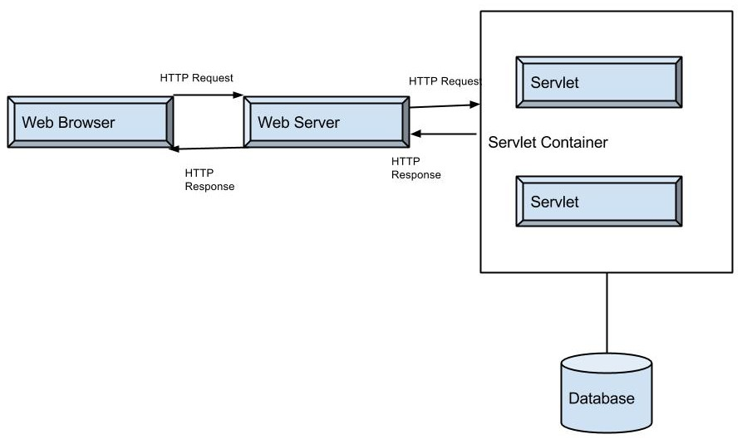
The process can be summarized as follows-
- A client sends a request to a Web Server, through a Web Browser.
- The Web Server searches for the required Servlet and initiates it.
- The Servlet then processes the client request and sends the response back to the server, which is then forwarded to the client.

Servlet API
The Servlet API is supported by all Servlet containers, such as Tomcat and Weblogic, etc. The Application Programming Interface (API) contains interface and classes to write a servlet program. The servlet API contains two packages as listed below-
javax.servlet – It contains a number of classes and interface that allows the servlet to access the basic services provided by the servlet container.
javax.servlet.http - The servlets using HTTP protocol are supported by the package javax.servlet.http.
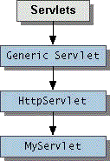
- A servlet is any class that implements the javax.servlet.Servlet interface. In practice, most servlets extend the javax.servlet.http.HttpServlet class. Some servlets extend javax.servlet.GenericServlet instead.

Generic Servlet
GenericServlet is an abstract class defined in the Servlet API. For implementing class we need to implement all the methods in javax.servlet.Servlet Interface. Most of the Servlet objects do not need initializing and destroying operations but still we need to implement all the methods in javax.servlet.Servlet interface. To solve this problem, Servlet API provides javax.servlet.GenericServlet which implements ServletConfig interface and provides the implementation for the methods in this interface except the service method.
GenericServlet is use for any Protocol whereas HttpServlet is used only for HTTP protocol. HttpServlet extends GenericServlet
- public void init (): This method is invoked by init (ServletConfig) method of GenericServlet. It is used to provide custom initializations without disturbing the initializations performed by GenericServlet in the init (ServletConfig) method.

- public void init (ServletConfig) : It is used to initialize the servlet. It indicates Servlet instance in being placed into the service.

- public abstract void service (ServletRequest request, ServletResponse response) : It is used to process user request. It is called by servlet container to intimate servlet about client request. It carries out single request from the client. ServletRequest object is used to collect data which is available with client requested data. ServletResponse object is used to generate the output content.

- public void destroy (): It indicates servlet instance is being taken out of service. It is used to clean up any resources that servlet might have initialized.

- public ServletConfig getServletConfig (): It returns ServletConfig interface reference. It is used to get configuration information from web.xml file.

- public ServletContext getServletContext (): It returns ServletContext object reference. It is used to get configuration information from web.xml file. It is also used to set, get or remove attribute from web.xml file. If information is changed then there is no need to modify the servlet. So it is easy to maintain.

- public String getInitParameter (String name): It returns the Servlet initialization parameter of the given name and if requested parameter is not available then it returns null.

- public Enumeration String getInitParameternames (): It returns names of all Servlet initialization parameters defined in web.xml file.

- public String getServletInfo (): It returns information about the respective servlet. For e.g. version, copyright.

- public String getServletName (): It returns the Servlet instance name defined in Deployment Descriptor (web.xml).

HttpServlet
HttpServlet is an abstract class defined in the Servlet API. It is abstract class with no abstract methods. Servlet container provides support for the Http protocol. It creates HttpServletRequest and HttpServletResponse objects if HTTP protocol is used for the sending request.
HttpServletRequest extends ServletRequest interface to provide request information for servlets. HttpServletResponse extends ServletResponse interface which provides functionality in sending response. HttpServlet is subtype of GenericServlet and does not override init, destroy and other methods. However, it implements the service () method which is abstract method in GenericServlet
HttpServlet is an abstract class which override Service(ServletRequest, ServletResponse) method of GenericServlet and call its own overloaded Service(HTTPServletRequest, HTTPServletResponse) method.
Here, getMethod() will return which type of method requested by client i.e. GET / POST / etc. Based on type of method, call goes to our Servlet either doGet / doPost / etc…

Servlet LifeCycle
Servlets are a small program that run at server side and creates dynamic web pages. Servlets respond to any type of requests sent by user. In MVC architecture servlet act as controller. The controller is the logic that processes and responds to the user requests. Life Cycle of Servlets contain following steps-
- Load servlet class - This step is invoked when either first time servlet is invoked or configured in the web.xml with load-on-startup element.
- Create servlet instance - Servlet specification declares one and only one servlet instance will be created for a single definition in the deployment descriptor.
We can define default constructor.
- Call the init method - After servlet instance is created, the web container initializes the parameters that were specified in the deployment descriptor. This method is invoked only when servlet is first loaded into memory.
- Call the service method- After the servlet component has been initialized, the web container can begin sending requests to that component using the service method .This method is used to process the request. For each request the web container will issue unique request and response to the service method.
When service () method is called by web container it invokes doGet (), doPost (), doPut (), doDelete (), doTrace (), doOptions (), getLastModified () methods.
- Call the destroy method - When a web application is being shut down web container will call destroy method. It is used to clean up any resources that servlet might have initialized.
We can override destroy method.

Deployment Descriptor
Web.xml is deployment descriptor and it is located in WEB-INF directory of web application. It defines mapping between URL paths and servlets that handle requests with those paths. The web.xml file provides configuration and deployment information for the Web components that comprise a Web application. The web.xml descriptor file represents the core of the java application.

Elements in Web.xml
Description of elements Used in web.xml file:
<web-aap>: This element represents whole application of web.xml file
<servlet>: This is the sub element of and represents the servlet
<servlet-name>: This is the sub element of servlet and used to represents the name of servlet
<servlet-class>: This is the sub element of servlet and used to represents the class of servlet
<servlet-mapping>: This is the sub element of and used to map the servlet
<url-pattern>: This is the sub element of servlet-mapping and used to client side to invoke the servlet

Welcome-file-list
This tag is used to specify the default page of web application if none is specified.
<welcome-file-list>

<welcome-file>avn.jsp</welcome-file>
<welcome-file>index.jsp</welcome-file>

</welcome-file-list>

Creating a Servlet using 2.4 servlet specification

Create new maven project “GpsServletOldApp”
- Create a maven based project “GpsServletOldApp”
- Add “servlet-api.jar dependencies
<dependency>
<groupId>javax.servlet</groupId>
<artifactId>servlet-api</artifactId>
<version>2.4</version>
</dependency>
- Add tomcat maven plugin
- Create a package “com.gps.java” inside “src/main/java”

Create a servlet class
- Create a Servlet class “MyFirstServlet.java” inside “com.gps.java” package
- Add servlet mapping into web.xml (Deployment Descriptor)
- Build Application into war

Deploy & Run Servlet application
- Start tomcat
- Deploy application into tomcat
- Test home page - http://localhost/GpsServletOldApp/
- Test servlet page- http://localhost/GpsServletOldApp/myFirstServlet
- Check Web Application directory structure inside GpsServletOldApp.war into target

Client page to execute servlet using hyperlink
- Create a folder “staticpage” for client program inside “webapp” folder
- Create a html page “myFirstPage.html” inside “staticpage”
- Build War
- Deploy App
- Test client page - http://localhost/GpsServletOldApp/staticpage/myFirstPage.html
- Click on Link “Link for my First Servlet” to test servlet

Client page to execute servlet using Form Submit
- Create a html page “formSubmit.html” inside “staticpage”
- Build War
- Deploy App
- Test client page - http://localhost/GpsServletOldApp/staticpage/formSubmit.html
- Click on button “Click here” to submit form

Class loading sequence
- Bootstrap classes of your JVM
- System class loader classes
- /WEB-INF/classes of your web application
- /WEB-INF/lib/*.jar of your web application
- Common class loader classes from Tomcat\lib

Difference between doGet / doPost
By Default, method type is GET always.
DoGet | DoPost
In doGet Method the parameters are appended to the URL and sent along with header information | In doPost, parameters are sent in separate line in the body
Maximum size of data that can be sent using doget is limted upto 4kb | There is no maximum size for data
Parameters are not encrypted | Parameters are encrypted
DoGet method generally is used to query or to get some information from the server | DoPost is generally used to update or post some information to the server
DoGet is faster if we set the response content length since the same connection is used. Thus increasing the performance | DoPost is slower compared to doGet since doPost does not write the content length
It can be Bookmarked. | It can’t.
Get is Idempotent. | Post is not Idempotent.

HelloWorldServlet.java
package com.src;

import java.io.IOException;
import java.io.PrintWriter;

import javax.servlet.ServletException;
import javax.servlet.http.HttpServlet;
import javax.servlet.http.HttpServletRequest;
import javax.servlet.http.HttpServletResponse;

public class HelloWorldServlet extends HttpServlet {

public void doGet(HttpServletRequest req, HttpServletResponse res)
throws IOException, ServletException {
System.out.println("Get Method is called.........");
doPost(req,res);
}

public void doPost(HttpServletRequest req, HttpServletResponse res)
throws IOException, ServletException {
System.out.println("Post Method is called.........");
res.setContentType("text/html");
PrintWriter pw = res.getWriter();
pw.println("<HTML><BODY><H1>Hello World Servlet</H1>");
pw.println("</BODY></HTML>");
pw.close();
}
}

Entry inside web.xml is:
<servlet>
<servlet-name>HelloWorldServlet</servlet-name>
<servlet-class>com.src.HelloWorldServlet</servlet-class>
</servlet>
<servlet-mapping>
<servlet-name>HelloWorldServlet</servlet-name>
<url-pattern>/HWS</url-pattern>
</servlet-mapping>

HelloWorldForm.html
<html>
<body>
<form action="/GpsServletNewApplication/HWS" method="post">
<table border="1" align="center">
<tr>
<td><b>Enter a Number<b></td>
<td><input type="text" name="num"></td>
</tr>
<tr>
<td><input type="submit" value="click"></td>
<td><input type="reset" value="reset"></td>
</tr>
</table>
</form>
</body>
</html>
- If User directly call Servlet from URL, then bydefault GET always called and Get will send call to POST
http://localhost:8080/GpsServletNewApplication/HWS
- If User call Servlet va POST then only POST will be called here
http://localhost:8080/GpsServletNewApplication/Staticpage/HelloWorldForm.html

Load Servlet on Server Startup
By default every servlet will be loaded when the container decides it needs to be loaded - typically on its
first access. But When ever server is starting, it is possible to tell the container to load a servlet on the startup. We can load any number of servlets on the startup. The <load-on-startup> sub-element indicates the order in which each servlet should be loaded. Lower positive values are loaded first. When loaded, the init() method of the servlet is called. Therefore this tag provides a good way to do the following:
1) Load a property file which will contain some settings for other Servlets / JSPs
2) Can handle stuff related to create a user-defined connection pool
For Example- <servlet>
<servlet-name>TestServlet</servlet-name>
<servlet-class>TestServlet</servlet-class>
<load-on-startup>1</load-on-startup>
</servlet>

Scope Object in Servlet / Sharing Information
There are four scope objects in servlets which enables sharing information between web components. The scope objects and their corresponding Java classes are listed below:
• Web Context – javax.servlet.ServletContext
• Session – javax.servlet.http.HttpSession
• Request – javax.servlet.HttpServletRequest
• Page – javax.servlet.jsp.PageContext
We can get attribute values from servlet scope objects using getAttribute method and set new values of attributes using setAttribute method.

Request Scope: Sending form parameter to the Servlet
User/client can send parameter from client to Server. Servlet which is running on Tomcat server can get this parameter using HTTPServletRequest, process on it and send back desired response to client.
Step-1: Create a HTML Form “Factorial_Form.html” which takes input from user. Let’s say to find factorial of a number. When user click on submit button of this form, a request send to Server with all parameters available into this form.
factorialForm.html
<!-- This form execute by Browser on client side -->
<html>
<body bgcolor=#ADCAFD>
<form action="/GpsServletNewApplication/findFactorial">
<table border="1">
<tr>
<td><b>Enter a Number</b></td>
<td><input type="text" name="num"></td>
</tr>
<tr>
<td><input type="submit" value="click"></td>
<td><input type="reset" value="reset"></td>
</tr>
</table>
</form>
</body>
</html>
URL to access this Form is: http://localhost:8080/GpsServletNewApplication/staticpage/factorialForm.html
Step-2: Create a Servlet “DisplayFactorial” inside package “src.com”
DisplayFactorial.java
package com.src;

import java.io.IOException;
import java.io.PrintWriter;

import javax.servlet.ServletException;
import javax.servlet.http.HttpServlet;
import javax.servlet.http.HttpServletRequest;
import javax.servlet.http.HttpServletResponse;

public class DisplayFactorial extends HttpServlet {
public void doGet(HttpServletRequest req, HttpServletResponse res)
throws IOException, ServletException {
res.setContentType("text/html");
PrintWriter out = res.getWriter();
String num = req.getParameter("num");
int n = Integer.parseInt(num);
int sum = 1;
for (int i = 1; i <= n; i++) {
sum = sum * i;
}
out.println("<HTML>");
out.println(" <BODY bgcolor=#ADDDDA>");
out.println("<h2>______Factoria of _" + n + " is " + sum + "__</h2>");
out.println(" </BODY>");
out.println("</HTML>");
}
}

Step-3: Make an entry for Servlet “DisplayFactorial” inside web.xml
<servlet>
<servlet-name>DisplayFactorial</servlet-name>
<servlet-class>com.src.DisplayFactorial</servlet-class>
</servlet>
<servlet-mapping>
<servlet-name>DisplayFactorial</servlet-name>
<url-pattern>/findFactorial</url-pattern>
</servlet-mapping>
Output of http://localhost:8080/GpsServletNewApplication/staticpage/factorialForm.html
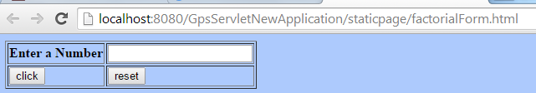
Enter a value “5” and click on “click” button to see the Result.
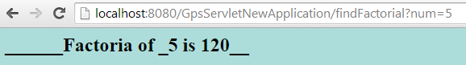

ServletConfig: Servlet Initialization
User/client can send parameter from client to Server. Servlet which is running on Tomcat server can get this parameter using HTTPServletRequest, process on it and send back desired response to client. But Suppose a scenario in which User has given any parameter and click on submit button to get the result. In this case, developer do not wants to display any error message on the screen. Instead they would like to access some default parameter or initial parameter which is specific to a Servlet then they have to use ServletConfig Object to access all initial parameter set inside a servlet.
Step-1: Create a HTML Form “Factorial_Form1.html” which takes input from user. Let’s say to find factorial of a number. When user click on submit button of this form, a request send to Server with all parameters available into this form.
Factorial_Form1.html
<!-- This form execute by Browser on client side -->
<html>
<body bgcolor=#ADCAFD>
<form action="/GpsServletNewApplication/findFactorial1">
<table border="1">
<tr>
<td><b>Enter a Number</b></td>
<td><input type="text" name="num"></td>
</tr>
<tr>
<td><input type="submit" value="click"></td>
<td><input type="reset" value="reset"></td>
</tr>
</table>
</form>
</body>
</html>
URL to access this Form is: http://localhost:8080/GpsServletNewApplication/Staticpage/Factorial_Form1.html
Step-2: Create a Servlet “DisplayFactorial1” inside package “src.com”
DisplayFactorial1.java
package com.src;

import java.io.IOException;
import java.io.PrintWriter;

import javax.servlet.ServletException;
import javax.servlet.http.HttpServlet;
import javax.servlet.http.HttpServletRequest;
import javax.servlet.http.HttpServletResponse;

public class DisplayFactorial1 extends HttpServlet {
String iNumber = "";

public void init() {
ServletConfig config = getServletConfig();
iNumber = config.getInitParameter("defaultVal");
}

public void doGet(HttpServletRequest req, HttpServletResponse res)
throws IOException, ServletException {
res.setContentType("text/html");
PrintWriter out = res.getWriter();
String num = req.getParameter("num");

if(num == null || num.trim().length()==0) {
num = iNumber;
}

int n = Integer.parseInt(num);
int sum = 1;
for (int i = 1; i <= n; i++) {
sum = sum * i;
}
out.println("<HTML>");
out.println(" <BODY bgcolor=#ADDDDA>");
out.println("<h2>______Factoria of _" + n + " is " + sum + "__</h2>");
out.println(" </BODY>");
out.println("</HTML>");
}
}

Step-3: Make an entry for Servlet “DisplayFactorial1” inside web.xml
<servlet>
<servlet-name>DisplayFactorial1</servlet-name>
<servlet-class>com.src.DisplayFactorial1</servlet-class>
<init-param>
<param-name>defaultVal</param-name>
<param-value>7</param-value>
</init-param>
</servlet>
<servlet-mapping>
<servlet-name>DisplayFactorial1</servlet-name>
<url-pattern>/findFactorial1</url-pattern>
</servlet-mapping>
Output of http://localhost:8080/GpsServletNewApplication/staticpage/Factorial_Form1.html
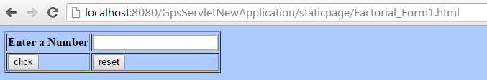

Don’t enter any value and click on “click” button to see the Result.
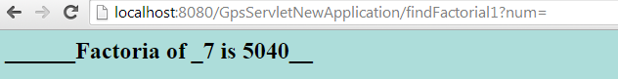
Question- What is difference between init() & init(ServletConfig)? OR What is wrong if i don't call super (ServletConfig) in the init(ServletConfig)?
If you override init(ServletConfig) method and don't call super(servletConfig) then the ServletConfig reference is not stored in the GenericServlet and if we call getServletConfig() we get null.
The reason we're advised to add super.init(config) is because GenericServlet.init(ServletConfig) stores a copy of the ServletConfig so that its getInitParameter() can forward the call to the ServletConfig object. If you override init(ServletConfig) in your own code you should add super.init(config) to preserve that functionality.
Another method of GenericServlet, init() is provided as a convenience. GenericServlet.init(ServletConfig) internally calls GenericServlet.init(). If you want to add functionality at init-time, you should do it by overriding init(). The default implementation of init(ServletConfig) will save the ServletConfig reference and then call your overriding init().

ServletContext: Web-Application Initialization
ServletContext is a interface which helps us to communicate with the servlet container. There is only one ServletContext for the entire web application and the components of the web application can share it. The information in the ServletContext will be common to all the components. Remember that each servlet will have its own ServletConfig. The ServetContext is created by the container when the web application is deployed and after that only the context is available to each servlet in the web application.
Steps to Initialize a Web-Application are as followings:
Step-1: Create name/value pair parameters using <Context-Param> attributes inside web.xml
<context-param>
<param-name>AdminUser</param-name>
<param-value>Amit</param-value>
</context-param>
<context-param>
<param-name>AdminPassword</param-name>
<param-value>Kumar</param-value>
</context-param>
Step-2: Access context parameter using following code inside any servlet
ServletContext context = getServletContext();
String admin = context.getInitParameter("AdminUser");
String password = context.getInitParameter("AdminPassword");

DisplayContextParam.java
package com.src;

import java.io.IOException;
import java.io.PrintWriter;

import javax.servlet.ServletContext;
import javax.servlet.ServletException;
import javax.servlet.http.HttpServlet;
import javax.servlet.http.HttpServletRequest;
import javax.servlet.http.HttpServletResponse;

public class DisplayContextParam extends HttpServlet{

public void doGet(HttpServletRequest req, HttpServletResponse res) throws IOException, ServletException {
res.setContentType("text/html");

ServletContext context = getServletContext();
String admin = context.getInitParameter("AdminUser");
String password = context.getInitParameter("AdminPassword");
System.out.println("Admin User: " + admin + " Password: " + password);

context.setAttribute("AnyObject", "We can Store any Object inside the context as an Attribute.");
String contextAttr = (String) context.getAttribute("AnyObject");
System.out.println("Value of Context Attribute (AnyObject): " + contextAttr);

context.setAttribute("AnyObject", "Attribute value can be changed any where within web application");
contextAttr = (String) context.getAttribute("AnyObject");
System.out.println("Changed Value of Context Attribute (AnyObject): " + contextAttr);

context.log(“Log the messages into the Log File…”);
}
}

Make an entry inside web.xml:
<servlet>
<servlet-name>DisplayContextParam</servlet-name>
<servlet-class>com.src.DisplayContextParam</servlet-class>
</servlet>
<servlet-mapping>
<servlet-name>DisplayContextParam</servlet-name>
<url-pattern>/printContext</url-pattern>
</servlet-mapping>

Execute above created Servlet: http://localhost:8080/GpsServletNewApplication/printContext
Output display at Server Console is:
Admin User: Amit Password: Kumar
Value of Context Attribute (AnyObject): We can Store any Object inside the context as an Attribute.
Changed Value of Context Attribute (AnyObject): Attribute value can be changed any where within web application
12 Apr, 2011 7:39:55 PM org.apache.catalina.core.ApplicationContext log
INFO: Testing to log a message into the Log file....

Request Dispatcher
RequestDispatcher class is mainly used to 'pass on' the current request to another program (servlet) and therefore allows 'chaining' of the programs. A RequestDispatcher primarily contains two methods include() and forward(). include() method includes the response of another program while forward() method forwards the request of the current program to another one.
RequestDispatcher.include()--→
This method includes the content of a resource in the response. The resource may either be a servlet, or a JSP page, or an HTML file.
Servlet1.java
package com.src.rd;
import java.io.IOException;
import java.io.PrintWriter;
import javax.servlet.ServletException;
import javax.servlet.http.HttpServlet;
import javax.servlet.http.HttpServletRequest;
import javax.servlet.http.HttpServletResponse;

public class Servlet1 extends HttpServlet {
public void doGet(HttpServletRequest req, HttpServletResponse res)
throws IOException, ServletException {
res.setContentType("text/html");
PrintWriter out = res.getWriter();
out.println("<HTML><BODY><br>Output of Servlet One<br></BODY></HTML>");
req.setAttribute("reqAttr1", "Servlet1 Request");
}
}

Servlet2.java
package com.src.rd;
import java.io.IOException;
import java.io.PrintWriter;
import javax.servlet.RequestDispatcher;
import javax.servlet.ServletException;
import javax.servlet.http.HttpServlet;
import javax.servlet.http.HttpServletRequest;
import javax.servlet.http.HttpServletResponse;
public class Servlet2 extends HttpServlet {
public void doGet(HttpServletRequest req, HttpServletResponse res)
throws IOException, ServletException {
res.setContentType("text/html");
PrintWriter out = res.getWriter();
out.println("<HTML><BODY><br>Output of Servlet Two<br>");
RequestDispatcher rd = getServletContext().getRequestDispatcher("/firstServlet");
rd.include(req, res);
out.println("<br>Attribute of First Servlet:" + req.getAttribute("reqAttr1")+"<br>");
out.println("</BODY></HTML>");
}
}
Make an Entry inside web.xml
<servlet>
<servlet-name>Servlet1</servlet-name>
<servlet-class>com.src.rd.Servlet1</servlet-class>
</servlet>
<servlet-mapping>
<servlet-name>Servlet1</servlet-name>
<url-pattern>/firstServlet</url-pattern>
</servlet-mapping>

<servlet>
<servlet-name>Servlet2</servlet-name>
<servlet-class>com.src.rd.Servlet2</servlet-class>
</servlet>
<servlet-mapping>
<servlet-name>Servlet2</servlet-name>
<url-pattern>/secondServlet</url-pattern>
</servlet-mapping>
Output after running Servlet2.java is: http://localhost:8080/GpsServletNewApplication/secondServlet
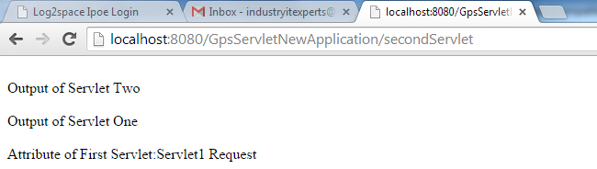
RequestDispatcher.forward()--→
The forward() method of RequestDispatcher forwards the request and response objects of ServletRequest and ServletResponse interface respectively to the path specified in getRequestDispatcher(String path). Any code written after forward(request, response) method will not execute as the request is already forwarded. As the client is not aware about this forward on the server therefore no history will be stored on the client and as a result backward and forward buttons does not work. This method is faster as compared to using sendRedirect because no network round trip to the server and back is required.
Servlet3.java
package com.src.rd;
import java.io.IOException;
import javax.servlet.RequestDispatcher;
import javax.servlet.ServletException;
import javax.servlet.http.HttpServlet;
import javax.servlet.http.HttpServletRequest;
import javax.servlet.http.HttpServletResponse;
public class Servlet3 extends HttpServlet {
public void doGet(HttpServletRequest req, HttpServletResponse res)
throws IOException, ServletException {
res.setContentType("text/html");
// PrintWriter out = res.getWriter();
// out.println("<HTML><BODY><br>Output of Servlet three<br>");
RequestDispatcher rd = getServletContext().getRequestDispatcher("/forthServlet");
req.setAttribute("reqAttr1", "Object1 Coming from Previous Servlet");
req.setAttribute("reqAttr2", "Object2 Coming from Previous Servlet");
rd.forward(req, res);
// out.println("<br>Attribute of First Servlet:" + req.getAttribute("reqAttr1")+"<br>");
// out.println("</BODY></HTML>");
}
}
Servlet4.java
package com.src.rd;
import java.io.IOException;
import java.io.PrintWriter;
import javax.servlet.ServletException;
import javax.servlet.http.HttpServlet;
import javax.servlet.http.HttpServletRequest;
import javax.servlet.http.HttpServletResponse;
public class Servlet4 extends HttpServlet {
public void doGet(HttpServletRequest req, HttpServletResponse res)
throws IOException, ServletException {
res.setContentType("text/html");
PrintWriter out = res.getWriter();
out.println("<HTML><BODY><br>Output of Forth Servlet <br>");
String str1 = (String) req.getAttribute("reqAttr1");
String str2 = (String) req.getAttribute("reqAttr2");
out.println("Output of previous servlet requested attribute1: " + str1);
out.println("Output of previous servlet requested attribute2: " + str2);
out.println("</BODY></HTML>");
}
}
Make an Entry inside web.xml
<servlet>
<servlet-name>Servlet3</servlet-name>
<servlet-class>com.src.rd.Servlet3</servlet-class>
</servlet>
<servlet-mapping>
<servlet-name>Servlet3</servlet-name>
<url-pattern>/thirdServlet</url-pattern>
</servlet-mapping>

<servlet>
<servlet-name>Servlet4</servlet-name>
<servlet-class>com.src.rd.Servlet4</servlet-class>
</servlet>
<servlet-mapping>
<servlet-name>Servlet4</servlet-name>
<url-pattern>/forthServlet</url-pattern>
</servlet-mapping>

Output after running Servlet2.java is: http://localhost:8080/GpsServletNewApplication/thirdServlet
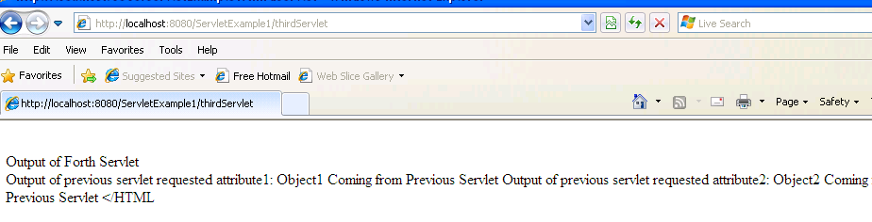
Question- What is difference between RequestDispatcher from ServletRequest and ServletContext ?
The difference between ServletRequest.getRequestDispatcher(String path) and ServletContext.getRequestDispatcher(String path) is that the former can accept a relative path as well whereas the latter can accept paths relative to the current context root only.
If the path starts with a '/' in the getRequestDispatcher(String path) of the ServletRequest interface then it's interpreted as being relative to the current context root otherwise it'll be a relative to the request of the calling servlet. Whereas, the path of the getRequestDispatcher(String path) of the ServletContext interface must start with '/' only - being relative to the current context root.
Another difference between the two is that path of the getRequestDispatche(String path) of the ServletRequest interface cannot extend outside the current servlet context whereas getRequestDispatcher(String path) of the ServletContext can use the getContext(String uripath) method to obtain RequestDispatcher for resources in foreign contexts.

Send Redirect
HttpServletResponse.sendRedirect () method Sends a temporary redirect response to the client using the specified redirect location URL. This method can accept relative URLs; the servlet container must convert the relative URL to an absolute URL before sending the response to the client. If the location is relative without a leading '/' the container interprets it as relative to the current request URI. If the location is relative with a leading '/' the container interprets it as relative to the servlet container root.
With a sendRedirect(), it is a new request from the client, and the only way to pass data is through URL parameters (url?name=value).
A sendRedirect() also updates the browser history. Suppose you have JSP-1 which has a form that targets Servlet-2, which then redirects to JSP-3. With a redirect, the user's address bar will read "http://[host]/JSP-3". If the user clicks the Reload/Refresh button, only JSP-3 will be re-executed, not Servlet-2.
SendRedirectForm.html
<html>

<head>
<title>New Page 1</title>
</head>

<body>

<form method="POST" action="/GpsServletNewApplication/sendRedirectServlet">
<p>Enter your name&nbsp;&nbsp;&nbsp;&nbsp;&nbsp;&nbsp;&nbsp;&nbsp; <input
type="text" name="username" size="20"></p>
<p>Enter your password&nbsp; <input type="text" name="password"
size="20"></p>
<p>&nbsp;&nbsp;&nbsp;&nbsp;&nbsp;&nbsp;&nbsp;&nbsp;&nbsp;&nbsp;&nbsp;&nbsp;
&nbsp;&nbsp;&nbsp;&nbsp;&nbsp;&nbsp;&nbsp;&nbsp;&nbsp;&nbsp;&nbsp;&nbsp;&nbsp;
&nbsp;&nbsp;&nbsp;&nbsp;&nbsp;&nbsp;&nbsp;&nbsp; <input type="submit"
value="Submit" name="B1"></p>
</form>

</body>

</html>

SendRedirectServlet.java
package com.src.rd;

import java.io.*;
import javax.servlet.*;
import javax.servlet.http.*;

public class SendRedirectServlet extends HttpServlet {
protected void doPost(HttpServletRequest request,
HttpServletResponse response) throws ServletException, IOException {
response.setContentType("text/html");
PrintWriter pw = response.getWriter();
String name = request.getParameter("username");
String password = request.getParameter("password");
if (name.equals("James") && password.equals("abc")) {
response.sendRedirect("http://www.google.com");
} else {
pw.println("u r not a valid user");
}
}
}

ValidUserServlet.java
package com.src.rd;

import java.io.*;
import javax.servlet.*;
import javax.servlet.http.*;

public class ValidUserServlet extends HttpServlet{
protected void doGet(HttpServletRequest request, HttpServletResponse response)
throws ServletException, IOException {
PrintWriter pw = response.getWriter();
pw.println("Welcome to ABCL............. " + " ");
pw.println("how are you");
}
}
Make an Entry inside web.xml
<servlet>
<servlet-name>SendRedirectServlet</servlet-name>
<servlet-class>com.src.rd.SendRedirectServlet</servlet-class>
</servlet>
<servlet-mapping>
<servlet-name>SendRedirectServlet</servlet-name>
<url-pattern>/sendRedirectServlet</url-pattern>
</servlet-mapping>

<servlet>
<servlet-name>ValidUserServlet</servlet-name>
<servlet-class>com.src.rd.ValidUserServlet</servlet-class>
</servlet>
<servlet-mapping>
<servlet-name>ValidUserServlet</servlet-name>
<url-pattern>/validUserServlet</url-pattern>
</servlet-mapping>
Output after running SendRedirectForm.html is: http://localhost:8080/GpsServletNewApplication/staticpage/SendRedirectForm.html
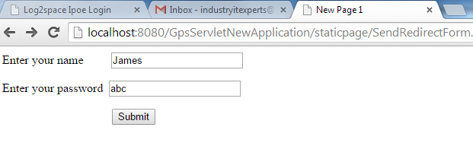
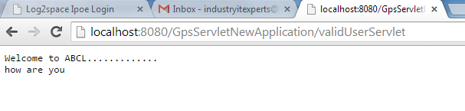
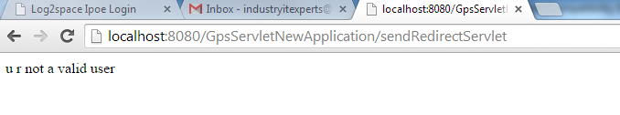

HttpSession: Session Handling
HTTP is a stateless protocol, so we need to maintain the user session. Session tracking can be done either of 4 ways:
- URL Rewriting (http://localhost:8080/.../?Name1=value1&Name2=value2&Name3=value3)
- Cookies (HttpServletRequest.getCookies())
- Hidden form fields (<input type=”hidden” name=”userlogin” value=”Amit” />)
- HttpSession (HttpSession - mostly preferred)
Using HttpSession:
Sessions are represented by an HttpSession object. We access a session by calling the HttpServletRequest.getSession() or HttpServletRequest.getSession(boolean) method of a request object. This method returns the current session associated with this request, or, if the request does not have a session, it creates one (unless boolean argument is false).
For Example-
Step-1: Create a HTML Form for Login Screen
Step-2: Create a Servlet to authenticate the user. If user authenticated set user login into the session and render a form
asking user name
Step-3: If user name is validated by passing through user session, then ask for user age by rendering a new form
Step-4: If user age is validated by passing though user session, session details are coming on screen

SessionHandlingPage.html
<!DOCTYPE html PUBLIC "-//W3C//DTD HTML 4.01 Transitional//EN" "http://www.w3.org/TR/html4/loose.dtd">
<html>
<head>
<meta http-equiv="Content-Type" content="text/html; charset=ISO-8859-1">
<title>Login Form</title>
</head>
<body>
<form name="loginForm" action="/GpsServletNewApplication/validateUserByHttpSession"
method="post">User Login: <input type="text" name="userlogin" /><br>
User Password: <input type="password" name="userpassword" /><br>
<input type="submit" name="submitBtn" /></form>
</body>
</html>
ValidateUserByHttpSession.java
package com.src.session;
import java.io.IOException;
import java.io.PrintWriter;
import javax.servlet.ServletException;
import javax.servlet.http.HttpServlet;
import javax.servlet.http.HttpServletRequest;
import javax.servlet.http.HttpServletResponse;
import javax.servlet.http.HttpSession;
import com.src.util.UserSessionConstant;
public class ValidateUserByHttpSession extends HttpServlet {
public void doGet(HttpServletRequest req, HttpServletResponse res) throws IOException, ServletException {
doPost(req, res);
}
public void doPost(HttpServletRequest req, HttpServletResponse res) throws IOException, ServletException {
// These 2 parameters name must be same as given into LoginForm.html
String userlogin = req.getParameter("userlogin");
String userpassword = req.getParameter("userpassword");
if (userlogin != null && userpassword != null) {
if (UserSessionConstant.USERLOGIN.equalsIgnoreCase(userlogin)
&& UserSessionConstant.PASSWORD.equalsIgnoreCase(userpassword)) {
System.out.println("User Login validated successfully.....");
HttpSession session = req.getSession();
// HttpSession session = req.getSession(true);
session.setAttribute(UserSessionConstant.USERLOGINATTRIBUTE,
UserSessionConstant.USERLOGIN);
res.setContentType("text/html");
PrintWriter out = res.getWriter();
out
.println("<HTML><BODY>HELLO: "
+ (String) session
.getAttribute(UserSessionConstant.USERLOGINATTRIBUTE)
+ "<BR></BR>");
out
.println("<FORM NAME='UserNameForm' ACTION='/GpsServletNewApplication/validateNameByHttpSession' METHOD='POST'>");
out.println("Name: <input type='text' name='username' />");
out.println("<input type='submit' name='SubmitBtn' />");
out.println("</FORM></BODY></HTML>");
out.close();
} else {
System.out.println("Invalid User / Passowrd.........");
}
} else {
System.out.println("Invalid User / Passowrd.........");
}
}
}
ValidateNameByHttpSession.java
package com.src.session;
import java.io.IOException;
import java.io.PrintWriter;
import javax.servlet.ServletException;
import javax.servlet.http.HttpServlet;
import javax.servlet.http.HttpServletRequest;
import javax.servlet.http.HttpServletResponse;
import javax.servlet.http.HttpSession;
import com.src.util.UserSessionConstant;
public class ValidateNameByHttpSession extends HttpServlet {
public void doGet(HttpServletRequest req, HttpServletResponse res)
throws IOException, ServletException {
doPost(req, res);
}
public void doPost(HttpServletRequest req, HttpServletResponse res)
throws IOException, ServletException {
HttpSession session = req.getSession(false);
if (session != null) {
String userlogin = (String) session
.getAttribute(UserSessionConstant.USERLOGINATTRIBUTE);
if(userlogin.equalsIgnoreCase(UserSessionConstant.USERLOGIN)) {
System.out.println("User Session exist for " + userlogin);
String username = req.getParameter("username");
if (username != null
&& username.trim().equalsIgnoreCase(
UserSessionConstant.USERNAME)) {
System.out.println("Username matching successfully....");
res.setContentType("text/html");
PrintWriter out = res.getWriter();
out
.println("<HTML><BODY>HELLO: "
+ (String) session
.getAttribute(UserSessionConstant.USERLOGINATTRIBUTE)
+ ". You are Loggen in. <BR></BR>");
out
.println("<FORM NAME='UserAgeForm' ACTION='/GpsServletNewApplication/validateAgeByHttpSession' METHOD='POST'>");
out.println("Age: <input type='text' name='userage' />");
out.println("<input type='submit' name='SubmitBtn' />");
out.println("</FORM></BODY></HTML>");
} else {
System.out.println("Username " + username + " does not matching.");
}
} else {
System.out.println("Invalid User....");
}
} else {
System.out.println("Session has expired....");
}
}
}

ValidateAgeByHttpSession.java
package com.src.session;
import java.io.IOException;
import java.io.PrintWriter;
import javax.servlet.ServletException;
import javax.servlet.http.HttpServlet;
import javax.servlet.http.HttpServletRequest;
import javax.servlet.http.HttpServletResponse;
import javax.servlet.http.HttpSession;

import com.src.util.UserSessionConstant;
public class ValidateAgeByHttpSession extends HttpServlet {
public void doGet(HttpServletRequest req, HttpServletResponse res)
throws IOException, ServletException {
doPost(req, res);
}
public void doPost(HttpServletRequest req, HttpServletResponse res)
throws IOException, ServletException {
HttpSession session = req.getSession(false);
if (session != null) {
String userlogin = (String) session
.getAttribute(UserSessionConstant.USERLOGINATTRIBUTE);
if (userlogin.equalsIgnoreCase(UserSessionConstant.USERLOGIN)) {
System.out.println("User Session exist for " + userlogin);
int userage = Integer.parseInt(req.getParameter("userage"));
if (userage == UserSessionConstant.USERAGE) {
System.out.println("Userage matching successfully....");

res.setContentType("text/html");
PrintWriter out = res.getWriter();
out
.println("<HTML><BODY>HELLO: "
+ (String) session
.getAttribute(UserSessionConstant.USERLOGINATTRIBUTE)
+ ". You are Loggen in. <BR></BR>");
out.println("</BODY></HTML>");

} else {
System.out.println("Userage " + userage
+ " does not matching.");
}
} else {
System.out.println("Invalid User....");
}
} else {
System.out.println("Session has expired....");
}
}
}
UserSessionConstant.java
package com.src.util;

public interface UserSessionConstant {

public static final String USERLOGIN = "Amit";
public static final String PASSWORD = "Kumar";

public static final String USERNAME = "Amit Kumar";
public static final int USERAGE = 30;

public static final String USERLOGINATTRIBUTE="USERLOGINATTRIBUTE";

}

Make an Entry inside web.xml
<servlet>
<servlet-name>ValidateUserByHttpSession</servlet-name>
<servlet-class>com.src.session.ValidateUserByHttpSession</servlet-class>
</servlet>
<servlet-mapping>
<servlet-name>ValidateUserByHttpSession</servlet-name>
<url-pattern>/validateUserByHttpSession</url-pattern>
</servlet-mapping>
<servlet>
<servlet-name>ValidateNameByHttpSession</servlet-name>
<servlet-class>com.src.session.ValidateNameByHttpSession</servlet-class>
</servlet>
<servlet-mapping>
<servlet-name>ValidateNameByHttpSession</servlet-name>
<url-pattern>/validateNameByHttpSession</url-pattern>
</servlet-mapping>
<servlet>
<servlet-name>ValidateAgeByHttpSession</servlet-name>
<servlet-class>com.src.session.ValidateAgeByHttpSession</servlet-class>
</servlet>
<servlet-mapping>
<servlet-name>ValidateAgeByHttpSession</servlet-name>
<url-pattern>/validateAgeByHttpSession</url-pattern>
</servlet-mapping>
Output after running LoginForm.html is: http://localhost:8080/GpsServletNewApplication/staticpage/LoginForm.html
User Login validated successfully.....
User Session exist for Amit
Username matching successfully....
User Session exist for Amit
Userage matching successfully....
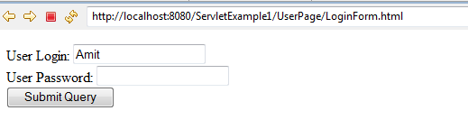
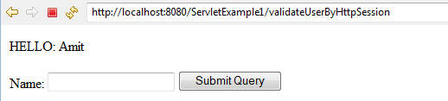
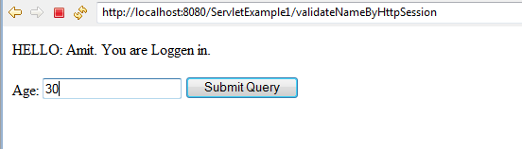
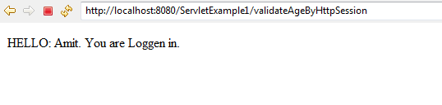

Using Cookies:
A cookie is a named piece of data (string) maintained by the browser that is sent to the server with every page request. The server can use that as a key to retrieve data associated with that user.
Use HttpServletRequest's getCookies() to get an array of all the cookies:
public Cookie[] getCookies()
Then, iterate through the array of Cookie objects until you find the cookie that you're looking for. The Cookie class has getName() and getValue() to get the name and value of the Cookie.
Only cookies stored by the accessed web application are submitted. Cookies from other web applications are not submitted.
For Example-
Step-1: Create a HTML Form for Login Screen
Step-2: Create a Servlet to authenticate the user. If user authenticated set user login into the cookies and render a form
asking user name
Step-3: If user name is validated by passing through cookies, then ask for user age by rendering a new form
Step-4: If user age is validated by passing though cookies, session details i.e. cookies are coming on screen

LoginForm1.html
<!DOCTYPE html PUBLIC "-//W3C//DTD HTML 4.01 Transitional//EN" "http://www.w3.org/TR/html4/loose.dtd">
<html>
<head>
<meta http-equiv="Content-Type" content="text/html; charset=ISO-8859-1">
<title>Login Form</title>
</head>
<body>
<form name="loginForm" action="/GpsServletNewApplication/validateUserByCookies"
method="post">User Login: <input type="text" name="userlogin" /><br>
User Password: <input type="password" name="userpassword" /><br>
<input type="submit" name="submitBtn" /></form>
</body>
</html>
ValidateUserByCookies.java
package com.src.session;
import java.io.IOException;
import java.io.PrintWriter;
import javax.servlet.ServletException;
import javax.servlet.http.Cookie;
import javax.servlet.http.HttpServlet;
import javax.servlet.http.HttpServletRequest;
import javax.servlet.http.HttpServletResponse;
import com.src.util.UserSessionConstant;
public class ValidateUserByCookies extends HttpServlet {
public void doGet(HttpServletRequest req, HttpServletResponse res)
throws IOException, ServletException {
doPost(req, res);
}
public void doPost(HttpServletRequest req, HttpServletResponse res)
throws IOException, ServletException {
// These 2 parameters name must be same as given into LoginForm1.html
String userlogin = req.getParameter("userlogin");
String userpassword = req.getParameter("userpassword");
if (userlogin != null && userpassword != null) {
if (UserSessionConstant.USERLOGIN.equalsIgnoreCase(userlogin)
&& UserSessionConstant.PASSWORD
.equalsIgnoreCase(userpassword)) {
System.out.println("User Login validated successfully.....");
Cookie cookies[] = req.getCookies();
Cookie cookie = null;
if (cookies == null) {
cookie = new Cookie(
UserSessionConstant.USERLOGINATTRIBUTE,
UserSessionConstant.USERLOGIN);
res.addCookie(cookie);
}
res.setContentType("text/html");
PrintWriter out = res.getWriter();
out
.println("<HTML><BODY><BR></BR>");
out
.println("<FORM NAME='UserNameForm' ACTION='/GpsServletNewApplication/validateNameByCookies' METHOD='POST'>");
out.println("Name: <input type='text' name='username' />");
out.println("<input type='submit' name='SubmitBtn' />");
out.println("</FORM></BODY></HTML>");
out.close();
} else {
System.out.println("Invalid User / Passowrd.........");
}
} else {
System.out.println("Invalid User / Passowrd.........");
}
}
}
ValidateNameByCookies.java
package com.src.session;
import java.io.IOException;
import java.io.PrintWriter;
import javax.servlet.ServletException;
import javax.servlet.http.Cookie;
import javax.servlet.http.HttpServlet;
import javax.servlet.http.HttpServletRequest;
import javax.servlet.http.HttpServletResponse;
import javax.servlet.http.HttpSession;
import com.src.util.UserSessionConstant;
public class ValidateNameByCookies extends HttpServlet {
public void doGet(HttpServletRequest req, HttpServletResponse res)
throws IOException, ServletException {
doPost(req, res);
}
public void doPost(HttpServletRequest req, HttpServletResponse res)
throws IOException, ServletException {
Cookie cookies[] = req.getCookies();
String userlogin = null;
if (cookies != null) {
for(Cookie cookie:cookies) {
String cookiename = cookie.getName();
if(cookiename.equalsIgnoreCase(UserSessionConstant.USERLOGINATTRIBUTE)) {
userlogin = cookie.getValue();
}
}
if(userlogin.equalsIgnoreCase(UserSessionConstant.USERLOGIN)) {
System.out.println("User Session exist for " + userlogin);
String username = req.getParameter("username");
if (username != null
&& username.trim().equalsIgnoreCase(
UserSessionConstant.USERNAME)) {
System.out.println("Username matching successfully....");
res.setContentType("text/html");
PrintWriter out = res.getWriter();
out
.println("<HTML><BODY>HELLO: "
+ userlogin
+ ". You are Loggen in. <BR></BR>");
out
.println("<FORM NAME='UserAgeForm' ACTION='/GpsServletNewApplication/validateAgeByCookies' METHOD='POST'>");
out.println("Age: <input type='text' name='userage' />");
out.println("<input type='submit' name='SubmitBtn' />");
out.println("</FORM></BODY></HTML>");
} else {
System.out.println("Username " + username + " does not matching.");
}
} else {
System.out.println("Invalid User....");
}
} else {
System.out.println("Session has expired....");
}
}
}

ValidateAgeByCookies.java
package com.src.session;
import java.io.IOException;
import java.io.PrintWriter;
import javax.servlet.ServletException;
import javax.servlet.http.Cookie;
import javax.servlet.http.HttpServlet;
import javax.servlet.http.HttpServletRequest;
import javax.servlet.http.HttpServletResponse;
import com.src.util.UserSessionConstant;
public class ValidateAgeByCookies extends HttpServlet {
public void doGet(HttpServletRequest req, HttpServletResponse res)
throws IOException, ServletException {
doPost(req, res);
}
public void doPost(HttpServletRequest req, HttpServletResponse res)
throws IOException, ServletException {
Cookie cookies[] = req.getCookies();
String userlogin = null;

if (cookies != null) {
for (Cookie cookie : cookies) {
String cookiename = cookie.getName();
if (cookiename
.equalsIgnoreCase(UserSessionConstant.USERLOGINATTRIBUTE)) {
userlogin = cookie.getValue();
}
}
if (userlogin.equalsIgnoreCase(UserSessionConstant.USERLOGIN)) {
System.out.println("User Session exist for " + userlogin);
int userage = Integer.parseInt(req.getParameter("userage"));
if (userage == UserSessionConstant.USERAGE) {
System.out.println("Userage matching successfully....");
res.setContentType("text/html");
PrintWriter out = res.getWriter();
out
.println("<HTML><BODY>HELLO: "
+ userlogin
+ ". You are Loggen in. <BR></BR>");
out.println("</BODY></HTML>");
} else {
System.out.println("Userage " + userage
+ " does not matching.");
}
} else {
System.out.println("Invalid User....");
}
} else {
System.out.println("Session has expired....");
}
}
}
UserSessionConstant.java
package com.src.util;

public interface UserSessionConstant {

public static final String USERLOGIN = "Amit";
public static final String PASSWORD = "Kumar";

public static final String USERNAME = "Amit Kumar";
public static final int USERAGE = 30;

public static final String USERLOGINATTRIBUTE="USERLOGINATTRIBUTE";

}

Make an Entry inside web.xml
<servlet>
<servlet-name>ValidateUserByCookies</servlet-name>
<servlet-class>com.src.session.ValidateUserByCookies</servlet-class>
</servlet>
<servlet-mapping>
<servlet-name>ValidateUserByCookies</servlet-name>
<url-pattern>/validateUserByCookies</url-pattern>
</servlet-mapping>
<servlet>
<servlet-name>ValidateNameByCookies</servlet-name>
<servlet-class>com.src.session.ValidateNameByCookies</servlet-class>
</servlet>
<servlet-mapping>
<servlet-name>ValidateNameByCookies</servlet-name>
<url-pattern>/validateNameByCookies</url-pattern>
</servlet-mapping>
<servlet>
<servlet-name>ValidateAgeByCookies</servlet-name>
<servlet-class>com.src.session.ValidateAgeByCookies</servlet-class>
</servlet>
<servlet-mapping>
<servlet-name>ValidateAgeByCookies</servlet-name>
<url-pattern>/validateAgeByCookies</url-pattern>
</servlet-mapping>
Output after running LoginForm.html is: http://localhost:8080/GpsServletNewApplication/staticpage/LoginForm1.html
User Login validated successfully.....
User Session exist for Amit
Username matching successfully....
User Session exist for Amit
Userage matching successfully....
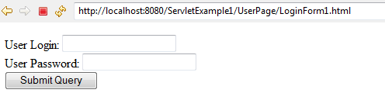
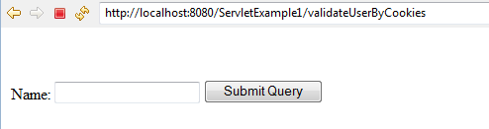
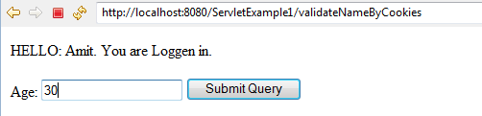
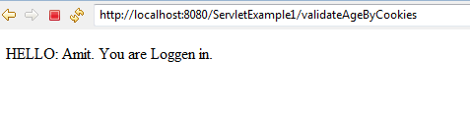

Configure Log4J
- Lo4j.jar should be inside “WEB-INF\lib”
- Log4.properties should be inside WEB-INF
- Configure web.xml
<context-param>
<param-name>log4j-config-location</param-name>
<param-value>log4j.properties</param-value>
</context-param>

<listener>
<listener-class>com.gps.java.ContextListener</listener-class>
</listener>
- Create Listener class to load properties files “ContextListener.java”
- User Logger everywhere in servlet / any other class

Listener
The servlet specification includes the capability to track key events in your Web applications through event listeners. This functionality allows more efficient resource management and automated processing based on event status.
For Example-
1) To count no. of visit of user
2) To do some processing during user session is created / destroyed
3) To do some processing when any attributes are added/removed from Request / Session / Context
4) To do some processing when Web-Application Context is intialized / destroyed
To achieve these functionalities we have various listerners in the form of Interface into Servlet API. Like –
HttpSessionListener, ServletContextListerner, ServletContextAttributeListener, HttpSessionAttributeListener, ServletRequestListener.
Steps to add a Listener are as followings:
1) Implement respective listener into your class
public class ABC extends HttpServlet implements HttpSessionListener
2) Define all methods into your class those which are present inside the listener
public void sessionCreated(HttpSessionEvent event){…}
public public void sessionDestroyed(HttpSessionEvent event) {….}
3) Make an entry into the web.xml under <listener>…</listener>
<listener>
<listener-class>ABC</listener-class>
</listener>
For Example-
Let us create a Servlet Listener that just counts the number of running http sessions and prints the details whenever a session gets created or destroy.
SessionListener.java
package com.src.listener;

import javax.servlet.http.HttpSessionEvent;
import javax.servlet.http.HttpSessionListener;

public class SessionListener implements HttpSessionListener {
private int sessionCount = 0;

public void sessionCreated(HttpSessionEvent event) {
synchronized (this) {
sessionCount++;
}
System.out.println("Session Created: " + event.getSession().getId());
System.out.println("Total Sessions: " + sessionCount);
}

public void sessionDestroyed(HttpSessionEvent event) {
synchronized (this) {
sessionCount--;
}
System.out.println("Session Destroyed: " + event.getSession().getId());
System.out.println("Total Sessions: " + sessionCount);
}
}
Make an Entry inside web.xml
<listener>
<description>sessionListener</description>
<listener-class>com.src.listener.SessionListener</listener-class>
</listener>
Output after running LoginForm.html is: http://localhost:8080/GpsServletNewApplication/UserPage/LoginForm.html
User Login validated successfully.....
Session Created: D7E3081AC3DC79D5EF999414760FAF40
Total Sessions: 1

Filter
A Servlet filter is an object that can intercept HTTP requests targeted at your web application.
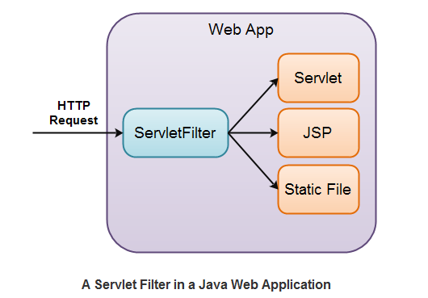
A filter is a program that runs on the server before the servlet or JSP page with which it is associated. A filter can be attached to one or more servlets or JSP pages and can examine the request information going into these resources. After doing so, it can choose among the following options.
• Invoke the resource (i.e., the servlet or JSP page) in the normal manner.
• Invoke the resource with modified request information.
• Invoke the resource but modify the response before sending it to the client.
• Prevent the resource from being invoked and instead redirect to a different resource, return a particular status
code, or generate replacement output.

This capability provides several important benefits. First, it lets you encapsulate common behavior in a modular and reusable manner. Remember, however, that filters work only in servers that are compliant with version 2.3 of the servlet specification. If your Web application needs to support older servers, you cannot use filters.

Real time examples-
  - Logging request parameters to log files.
  - Authentication and authorization of request for resources.
  - Formatting of request body or header before sending it to servlet.
  - Compressing the response data sent to the client.
  - Alter response by adding some cookies, header information etc.

For Example:
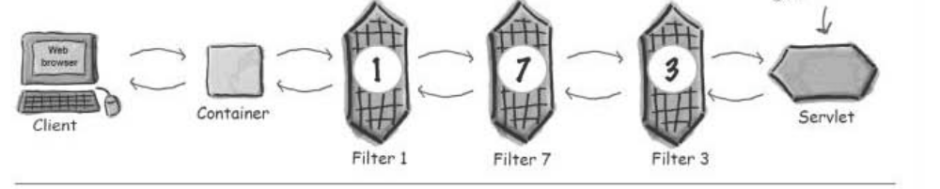
Do you have 30 different servlets or JSP pages that need to compress their content to decrease download time? No problem: make a single compression filter and apply it to all 30 resources.

Life Cycle of Filter-
init() -> doFilter() -> destroy()

Creating a filter involves five basic steps:
1. Create a class that implements the Filter interface.
2. Put the filtering behavior in the doFilter method. The first argument to the doFilter method is a
ServletRequest object. This object gives your filter full access to the incoming information, including form
data, cookies, and HTTP request headers. The second argument is a ServletResponse; it is mostly ignored in
simple filters. The final argument is a FilterChain; it is used to invoke the servlet or JSP page as described in the
next step.
3. Call the doFilter method of the FilterChain object. The doFilter method of the Filter interface takes a FilterChain object as one of its arguments. When you call the doFilter method of that object, the next
associated filter is invoked. If no other filter is associated with the servlet or JSP page, then the servlet or page
itself is invoked.
4. Register the filter with the appropriate servlets and JSP pages. Use the filter and filter-mapping elements in
the deployment descriptor (web.xml).
When filters are registered, they are registered according to the order specified inweb.xml.

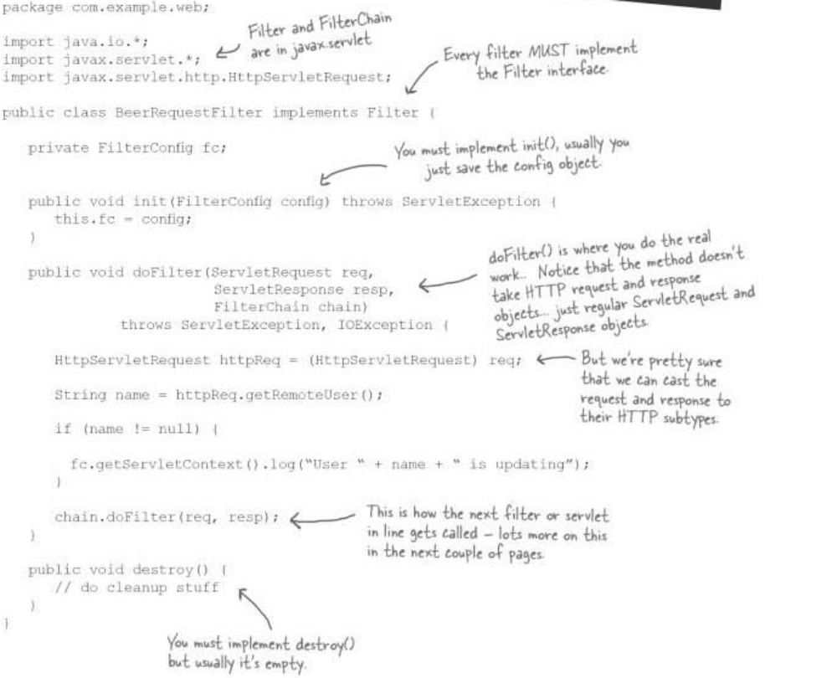

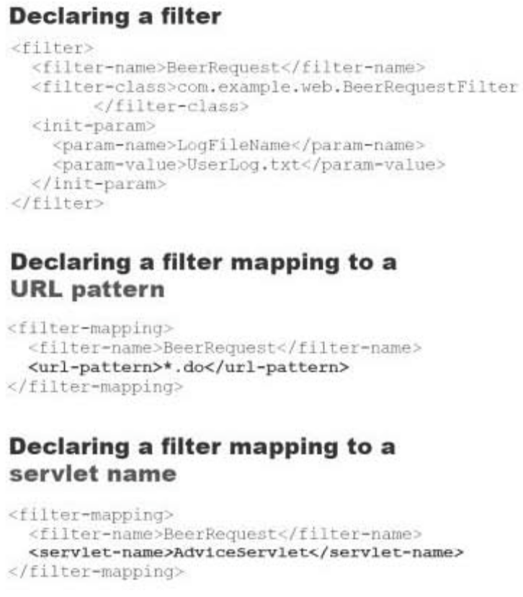
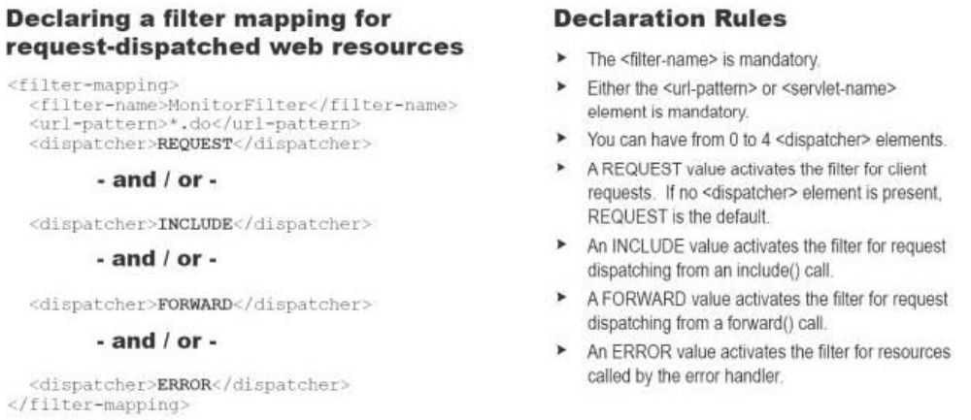
- A REQUEST value activates the filter for client requests. If no <dispatcher> element is present, REQUEST is the default.
- An INCLUDE value activates the filter for request dispatching from an include() call
- A FORWARD value activates the filter for request dispatching from a forward() call
- An ERROR value activates the filter for resources called by the error handler

Why a GZip Servlet Filter?
You could implement GZip compression in each and every Servlet or JSP in your application if you wanted to. But that gets clumsy.
The smart thing about a GZip Servlet filter is that it is executed before and after any Servlet, JSP, or even static files. That way you can create a single servlet filter that enables GZip compression for all content that needs it. The Servlets, JSPs etc. don't even know that the content is being compressed, because it happens in the Servlet filter. The GZip Servlet filter enables GZip compression, sets the right HTTP headers, and makes sure that content written by Servlets, JSPs etc. is compressed.

GZip Servlet Filter Design
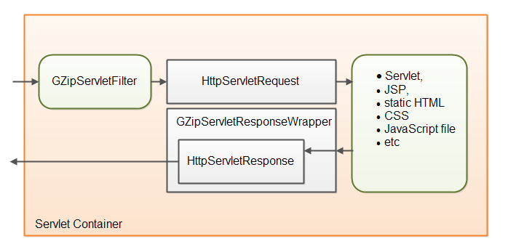
First you need a Servlet filter class. That class is mapped to a set of URL's in the web.xml file.
When an HTTP request arrives at the Servlet container which is mapped to the filter, the filter intercepts the request before it is handled by the Servlet, JSP etc. which the request is targeted at. The GZip servlet filter checks if the client (browser) can accept GZip compressed content. If yes, it enables compression of the response.
GZip compression of the response is enabled by wrapping the HttpServletResponse object in aGZipServletResponseWrapper. This wrapper is passed to the Servlet, JSP etc. which handles the request. When the Servlet, JSP etc. writes output to be sent to the browser, it does so to the response wrapper object. The Servlet, JSP etc. cannot see the difference between a real HttpServletResponse and the wrapper object. The response wrapper object then compresses the written content and writes the compressed content to the HttpServletResponse.
Example- com.gps.filter. GZipServletFilter.java, com.gps.filter .GZipServletResponseWrapper.java, web.xml

Servlets - Exception Handling
When a servlet throws an exception, the web container searches the configurations in web.xml that use the exception-type element for a match with the thrown exception type.
You would have to use the error-page element in web.xml to specify the invocation of servlets in response to certain exceptions or HTTP status codes.

web.xml Configuration for Error Handling
Consider, you have an ErrorHandler servlet which would be called whenever there is any defined exception or error. Following would be the entry created in web.xml.
<!-- servlet definition -->
<servlet>
<servlet-name>ErrorHandler</servlet-name>
<servlet-class>ErrorHandler</servlet-class>
</servlet>
<!-- servlet mappings -->
<servlet-mapping>
<servlet-name>ErrorHandler</servlet-name>
<url-pattern>/ErrorHandler</url-pattern>
</servlet-mapping>

<!-- error-code related error pages -->
<error-page>
<error-code>404</error-code>
<location>/ErrorHandler</location>
</error-page>
<error-page>
<error-code>403</error-code>
<location>/ErrorHandler</location>
</error-page>

<!-- exception-type related error pages -->
<error-page>
<exception-type>
javax.servlet.ServletException
</exception-type >
<location>/ErrorHandler</location>
</error-page>

<error-page>
<exception-type>java.io.IOException</exception-type >
<location>/ErrorHandler</location>
</error-page>

<error-page>
<exception-type>java.lang.Throwable</exception-type >
<location>/ErrorHandler</location>
</error-page>

Servlet Concurrency
A Java servlet container / web server is typically multithreaded. That means, that multiple requests to the same servlet may be executed at the same time. Therefore, you need to take concurrency into consideration when you implement your servlet.
To make sure that a servlet is thread safe, there are a few basic rules of thumb you must follow:
- Your servlet service() method should not access any member variables, unless these member variables are thread safe themselves.
- Your servlet service() should not reassign member variables, as this may affect other threads executing inside the service() method. If you really, really need to reassign a member variable, make sure this is done inside a synchronized block.
- Rule 1 and 2 also counts for static variables.
- Local variables are always thread safe. Keep in mind though, that the object a local variable points to, may not be so. If the object was instantiated inside the method, and never escapes, there will be no problem. On the other hand, a local variable pointing to some shared object, may still cause problems. Just because you assign a shared object to a local reference, does not mean that object automatically becomes thread safe.
The request and response objects are of course thread safe to use. A new instance of these are created for every request into your servlet, and thus for every thread executing in your servlet.
Of course it is not only the member variables and static variables inside the servlet class itself, that you need to be careful about accessing. Static variables in any other class which are accessed by your servlet, must also be thread safe. The same is true for member variables of any shread objects accessed by your servlet.
public class SimpleHttpServlet extends HttpServlet {
// Not thread safe, static.
protected static List list = new ArrayList();
// Not thread safe
protected Map map = new HashMap();
// Thread safe to access object, not thread safe to reassign variable.
protected Map map = new ConcurrentHashMap();
// Thread safe to access object (immutable), not thread safe to reassign variable.
protected String aString = "a string value";
protected void doGet( HttpServletRequest request, HttpServletResponse response)
throws ServletException, IOException {
// Not thread safe, unless the singleton is 100% thread safe.
SomeClass.getSomeStaticSingleton();
// Thread safe, locally instantiated, and never escapes method.
Set set = new HashSet();
}
}

